WORK, ENERGY AND POWER
QUESTION 1

A worker pulls a crate of mass 30 kg from rest along a horizontal floor by applying a constant force of magnitude 50 N at an angle of 30° to the horizontal. A frictional force of magnitude 20 N acts on the crate whilst moving along the floor.
30°
50 N
6 m
30 kg
P
O

1.1 Draw a labelled free-body diagram to show ALL the forces acting on the crate during
its motion.
1.2 Give a reason why each of the vertical forces acting on the crate do NO WORK on
the crate.
1.3 Calculate the net work done on the crate as it reaches point P, 6 m from the starting
point O.
1.4 Use the work-energy theorem to calculate the speed of the crate at the instant it
reaches point P.
1.5 The worker now applies a force of the same magnitude, but at a SMALLER ANGLE to
the horizontal, on the crate.

How does the work done by the worker now compare to the work done by the worker in QUESTION 1.3? Write down only GREATER THAN, SMALLER THAN or EQUAL TO.

Give a reason for the answer. (No calculations are required.)

QUESTION 2
A rescue helicopter is stationary (hovers) above a soldier. The soldier of mass 80 kg is lifted vertically upwards through a height of 20 m by a cable at a CONSTANT SPEED of 4 m∙s⁻¹. The tension in the cable is 960 N. Assume that there is no sideways motion during the lift. Air friction is not to be ignored.

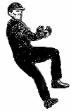
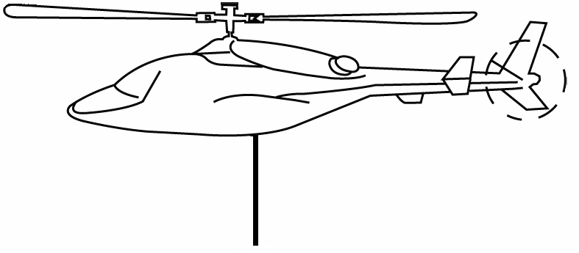
960 N
80 kg

2.1 State the work-energy theorem in words.
2.2 Draw a labelled free-body diagram showing ALL the forces acting on the soldier while
being lifted upwards.
2.3 Write down the name of a non-contact force that acts on the soldier during the upward
lift.
2.4 Use the WORK-ENERGY THEOREM to calculate the work done on the soldier by
friction after moving through the height of 20 m.

QUESTION 3
The bounce of a cricket ball is tested before it is used. The standard test is to drop a ball from a certain height onto a hard surface and then measure how high it bounces.

During such a test, a cricket ball of mass 0,15 kg is dropped from rest from a certain height and it strikes the floor at a speed of 6,2 m∙s⁻¹. The ball bounces straight upwards at a velocity of
3,62 m∙s⁻¹ to a height of 0,65 m, as shown in the diagram below. The effects of air friction may be ignored.
0,65 m
0,15 kg

3.1 Define the term impulse in words.
3.2 Calculate the magnitude of the impulse of the net force applied to the ball during its
collision with the floor.
3.3 To meet the requirements, a cricket ball must bounce to one third of the height that
it is initially dropped from.
Use ENERGY PRINCIPLES to determine whether this ball meets the minimum requirements.

QUESTION 4
A wooden block of mass 2 kg is released from rest at point P and slides down a curved slope from a vertical height of 2 m, as shown in the diagram below. It reaches its lowest position, point Q, at a speed of 5 m∙s⁻¹.
2 m
P
Q
2 kg
9 kg

4.1 Define the term gravitational potential energy.
4.2 Use the work-energy theorem to calculate the work done by the average frictional
force on the wooden block when it reaches point Q.
4.3 Is mechanical energy conserved while the wooden block slides down the slope?
Give a reason for the answer.
4.4 The wooden block collides with a stationary crate of mass 9 kg at point Q. After the collision, the crate moves to the right at 1 m∙s⁻¹.
4.4.1 Calculate the magnitude of the velocity of the wooden block immediately after
the collision.
4.4.2 The total kinetic energy of the system before the collision is 25 J. Use a
calculation to show that the collision between the wooden block and the crate
is inelastic.

QUESTION 5
A 3 kg block slides at a constant velocity of 7 m‧s⁻¹ along a horizontal surface. It then strikes a rough surface, causing it to experience a constant frictional force of 30 N. The block slides 2 m under the influence of this frictional force before it moves up a frictionless ramp inclined at an angle of 20° to the horizontal, as shown in the diagram below.

The block moves a distance d up the ramp, before it comes to rest.
3 kg
3 kg
2 m
d
20°
7 m‧s⁻¹

5.1 Show by calculation that the speed of the block at the bottom of the ramp is 3 m‧s⁻¹.
5.2 Draw a free-body diagram to show all the forces acting on the block in a direction
parallel to the incline, whilst the block is sliding up the ramp.
5.3 Calculate the distance, d, the block slides up the ramp.

QUESTION 6
John applies a force F to help his friend in a wheelchair to move up a ramp of length 10 m and a vertical height of 1,5 m, as shown in the diagram below. The combined mass of his friend and the wheelchair is 120 kg. The frictional force between the wheels of the wheelchair and the surface of the ramp is 50 N. The rotational effects of the wheels of the wheelchair may be ignored.

The wheelchair moves up the ramp at constant velocity.


h = 1,5 m
10 m
F

6.1 What is the magnitude of the net force acting on the wheelchair as it moves up the
ramp? Give a reason for your answer.
6.2 What is the magnitude of the net work done on the wheelchair on reaching the top
of the ramp?
6.3 Calculate the following:
6.3.1 Work done on the wheelchair by force F
6.3.2 The magnitude of force F exerted on the wheelchair by John

QUESTION 7
The diagram below represents how water is funnelled into a pipe and directed to a turbine at a hydro-electric power plant. The force of the falling water rotates the turbine.

Each second, 200 m³ of water is funnelled down a vertical shaft to the turbine below. The vertical height through which the water falls upon reaching the turbine is 150 m. Ignore the effects of friction.

NOTE: One m³ of water has a mass of 1 000 kg.
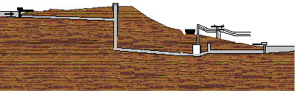
150 m
turbine
water inflow

7.1 Calculate the mass of water that enters the turbine each second.
7.2 Calculate the kinetic energy of this mass of water when entering the turbine. Use
energy principles.
7.3 Calculate the maximum speed at which this mass of water enters the turbine.
7.4 Assume that a generator converts 85% of this maximum kinetic energy gained by the
water into hydro-electricity. Calculate the electrical power output of the generator.
7.5 Explain what happens to the 15% of the kinetic energy that is NOT converted into
electrical energy.

FORMULAE
